Tempe Diablos Charities
Board of Directors Meeting
Agenda

Wednesday, July 20th, 2022
6:00 P.M. – Peoples Mortgage Training Room

Agenda

Attendance: Stainton, Morris, Brad Cox, Bryan Cox, DiDomenico, Vasquez, Helmers, Rojas, Pizzi, Honeycutt, Homes, Frias, Cox, Garcia

Guests: Personale, Passante, Antonio

Call to Order: 6:04pm

Approval of Minutes – April 25th, 2022

Motion - Helmers
Second – Cox, Brad
Minutes – Passes

Outgoing Chairman’s Report - Antonio
- Goal for Meeting
  - Elections – Chairman, Asst. Chair, and Secretary / Treasurer
Chairman – Jamey Helmers
Assist Chair – Greg Stainton
Sec/Treasurer – Brad Cox
Motion – DiDomenico
Second – Morris
Motion Passes
Floor is relinquished to the new Chairman – Jamey Helmers
  - New Chairman Goals
Chairman – Discussion on history and past with the Diablos. 3rd year on board and like the direction that the Board is going, will focus on the Financials and schedule a discussion with the new CPA. Would like to concentrate on adding new Community Members to the Board. Garcia, Honeycutt, and Ottinger to contact Potentials for interest. Antonio to send out Candidate Forms for use. Discussion on approach of Community Members and affiliations. Set up a Grant Reception Event and benefits of holding a community networking event.
  - Approve 2022/2023 Budget
  - Approve Proposed Grant Funding Amounts
  - Discuss future direction

- Update on Check Presentations
All Checks have been delivered

Outgoing Treasurer’s Report – Passante / Honeycutt
Discussion on changes made over year. Balance Sheet ties, a couple items listed out on the Balance Sheet the Scholarship accounts. One account (Diablo) will need to be moved over to the C6 organization. Sorgatz Fund on the Balance Sheet was monies listed as a restricted account and was a fund of cash held in an account, the Finance committee will look into this account and future direction.

Group decided to wait until a full financial statement is delivered prior to approving financials for Year End. Jamey will send out the financials. Thought is having the CPA present the financials to the Board. A Zoom will be scheduled for a future date. (2nd week in August)

Motion – No Motion

Action/ Discussion Items
- Budget / Grant Funding
  - Approve Budget –
Change the name to Use of Funds for the money received in our accounts. A meeting will be set up via Zoom to discuss funding sources and the financials next week. (Tuesday or Wednesday)

Motion – Morris
Second – Homes
Abstained – Pizzi
Motion Passes

  - Grant Funding Amounts

Item for Lili’s Pad – Seen update that they have a building, would need to verify with Program. – Take the restriction off this grant request

City of Tempe - Helping Us Grow - $5,000 – amount is approved, but await distribution of money.

- Community Members Nominations
No Report

- Old business -

Please all members of the board sign a conflict of interest form and turn into Jamey. Need DiDomenico, Brad Cox, Vasquez, Ottinger, Honeycutt. Please email to jhelmers@cox.net
- New business
  - Grant Award Reception – Personale
Already Discussed

- Meeting Adjourn

Motion – Brad Cox
Second - Ottinger
Meeting Adjourned
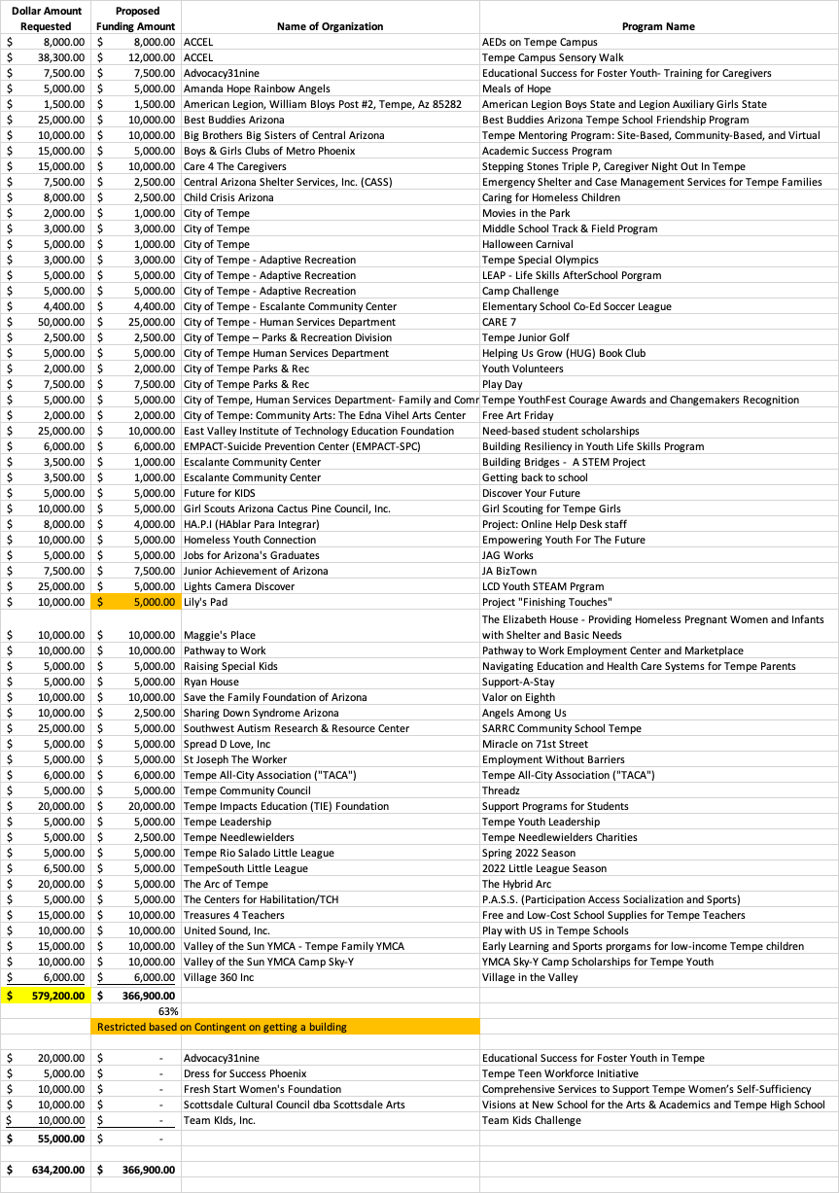
CH
A
I
RM
A
N
O
pe
n
T
e
r
m
:
2 Y
e
a
r
s
CO
M
M
U
N
I
T
Y

DI
R
E
C
T
OR
S
U
p t
o 5 M
e
m
be
r
s
T
e
r
m
:
2 Y
e
a
r
s
R
e
ne
w
a
bl
e
/
6 Y
e
a
r
s
M
a
x
M
a
r
ga
r
e
t
H
one
yc
ut
t
L
or
r
a
i
ne
F
r
i
a
s
O
pe
n C
om
m
uni
t
y M
e
m
be
r
O
pe
n C
om
m
uni
t
y M
e
m
be
r
O
pe
n C
om
m
uni
t
y M
e
m
be
r
+
10 Y
R
. D
I
A
B
L
O
U
p t
o 6 M
e
m
be
r
s
T
e
r
m
:
3 Y
e
a
r
s
J
a
i
m
e
y H
e
l
m
e
r
s
R
us
s
H
om
e
s
S
t
a
n M
or
r
i
s
B
i
l
l
O
t
t
i
nge
r
M
i
ke
P
i
z
z
i
G
r
e
g S
t
a
i
nt
on
<
5yr
D
I
A
B
L
O
S

AC
T
I
VE
U
p t
o 2 M
e
m
be
r
T
e
r
m
:
1 Y
e
a
r
B
r
ya
n C
ox
J
us
t
i
n R
oj
a
s
C
U
R
R
E
N
T
D
I
A
B
L
O
S
SE
C
R
E
T
A
R
Y

/
T
R
E
A
S
U
R
E
R
V
i
nc
e
V
a
s
que
z
T
e
r
m
:
1 Y
e
a
r
SE
C
R
E
T
A
R
Y

/
T
R
E
A
S
U
R
E
R
O
pe
n
T
e
r
m
:
1Y
e
a
r
V
I
C
E
C
H
A
I
R
M
A
N
O
pe
n
T
e
r
m
:
1Y
e
a
r
EX
EC
U
TI
V
E
DI
R
E
C
T
OR
P
os
i
t
i
on a
s
ne
e
de
d
T
e
r
m
:
I
nde
f
i
ni
t
e
N
on
-
V
ot
i
ng M
e
m
be
r
T
H
E
T
E
M
P
E
D
I
A
B
L
O
S
C
H
A
R
I
T
I
E
S
501(
c
)
(
3)
U
P
T
O
12 T
E
M
P
E
D
I
A
B
L
O
S
A
N
D
U
P
T
O
5
C
O
M
M
U
N
I
T
Y
D
I
R
E
C
T
O
R
S
M
A
Y
S
E
R
V
E
I
N

T
H
E
C
A
P
A
C
I
T
Y
A
S
A
C
O
R
P
O
R
A
T
E
O
F
F
I
C
E
R

O
R
B
O
A
R
D
M
E
M
B
E
R
I
N
T
H
E

T
E
M
P
E
D
I
A
B
L
O
S
C
H
A
R
I
T
I
E
S
T
h
e
C
h
ai
r
s
of
t
h
e
C
h
ar
i
t
i
e
s
B
oar
d
i
s
e
l
e
c
t
e
d

p
os
i
t
i
on
s
f
r
om
t
h
e
e
xi
s
t
i
n
g B
oar
d
as
d
e
s
c
r
i
b
e
d

ab
ove
.
C
U
R
R
E
N
T
D
I
A
B
L
O
S
V
I
C
E
P
R
E
S
I
D
E
N
T
S
G
r
e
g G
a
r
c
i
a
B
r
a
d C
ox
T
e
r
m
:
1Y
e
a
r
C
U
R
R
E
N
T
D
I
A
B
L
O
S
PR
E
SI
D
E
N
T
M
i
ke
D
i
D
om
e
ni
c
o
T
e
r
m
:
1Y
e
a
r
T
e
m
p
e
D
i
ab
l
o C
h
ar
i
t
i
e
s
501c
3
2022
-
2023

